Springboot: Kafka products producer and consumer application

Overview:

* Kafka producer sends list of products to a topic named: **productsTopic**
* Before sending product to the topic, it is check if the product is already present in database
* Source data for kafka producer is a Rest API
* Two consumers subscribeto a topic named: **productsTopic** with group name**: my_products_group1**
* I used consumer group to distribute the load
* After consuming the product save it in mysql database

Steps to demonstrate this kafka application:

IDE: IntelliJ, (I find it easy for running the scrips batch files as this IDE supports .cmd files execution)

Project structure:

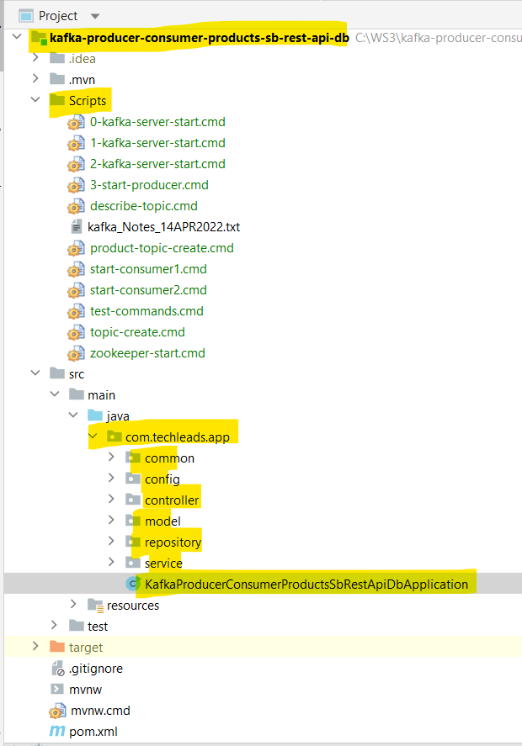

**Start zookeeper server**

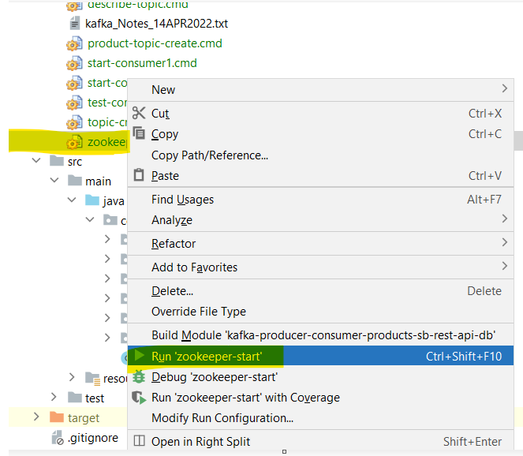

**Similarly start 3 kafka servers**

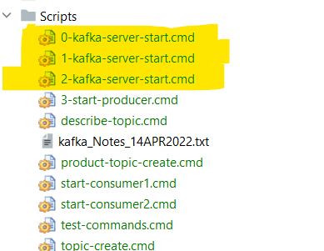

**Now create the topc**

*%CONFLUENT_HOME%*\bin\windows\kafka-topics.bat --create --topic productsTopic --partitions 3 --replication-factor 3 --bootstrap-server localhost:9092

**Now start two consumers**

1. *%CONFLUENT_HOME%*\bin\windows\kafka-console-consumer.bat --bootstrap-server localhost:9092 --topic productsTopic --from-beginning --group **my_products_group1**
2. *%CONFLUENT_HOME%*\bin\windows\kafka-console-consumer.bat --bootstrap-server localhost:9092 --topic productsTopic --from-beginning --group **my_products_group1**

**Now start the producer java application**

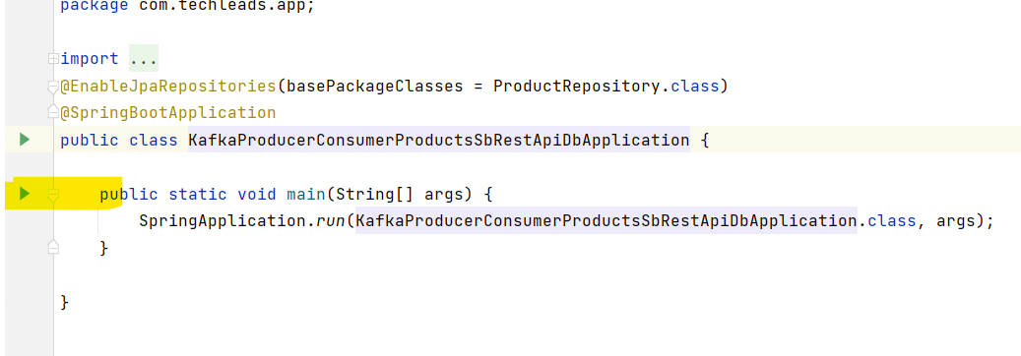

**Send list of 100 products to kafka producer from a rest API**

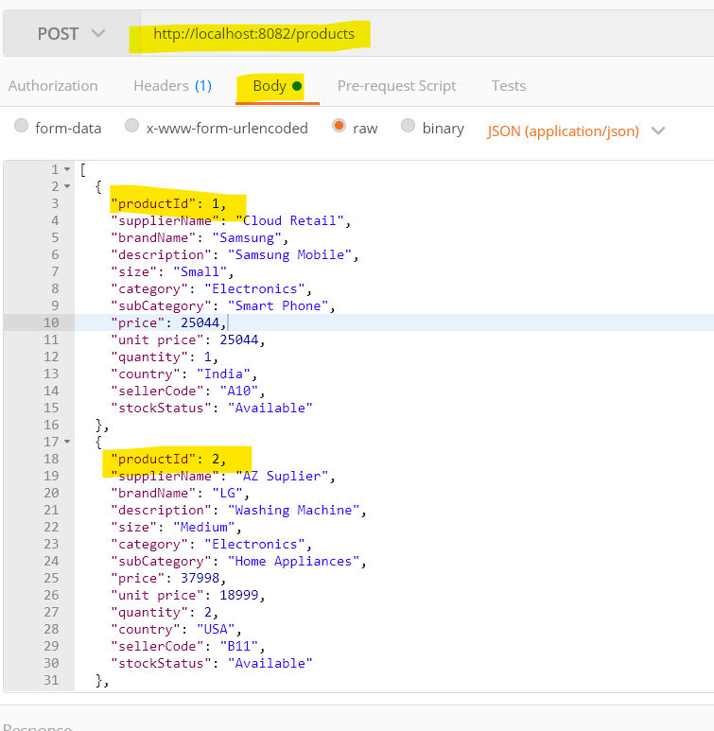

**Now check the consumers:**

**Consumer-1**

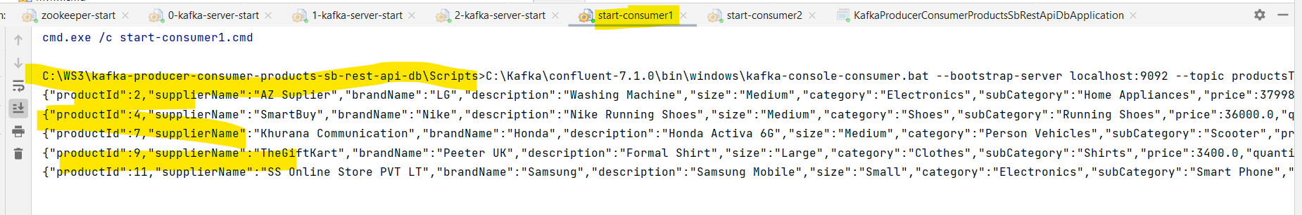

**Consumer-2**

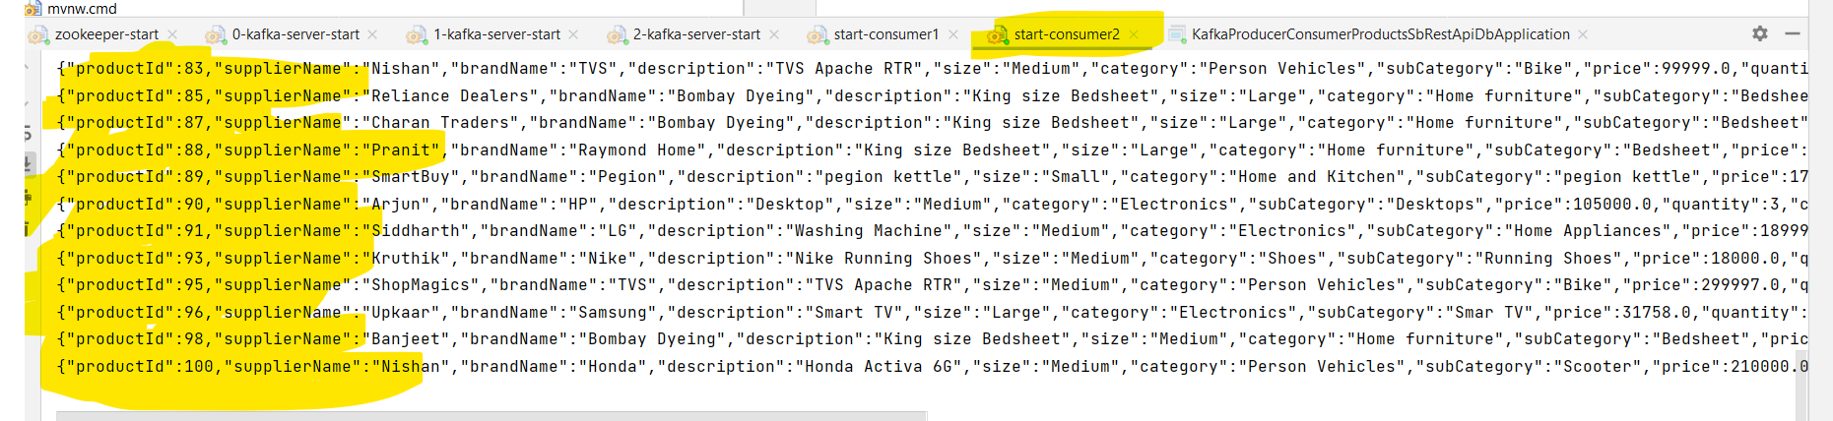

**Now check if the products are saved in mysql database**

